Alexander Baldree
1/20/26
CSD340
Module 3 Assignment 3.2

GitHub Link:
https://github.com/Panda-Alex21687/CSD340

Index Page:
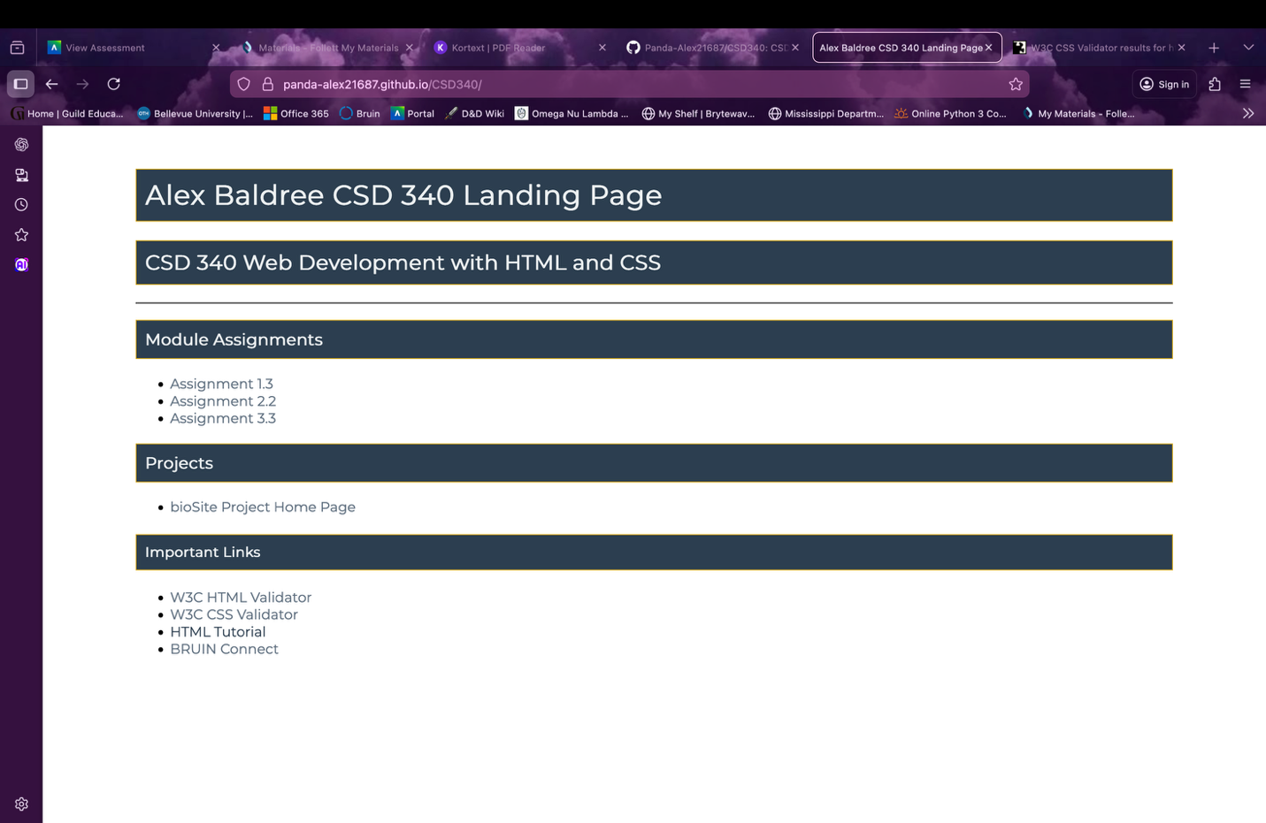

HTML Validator:
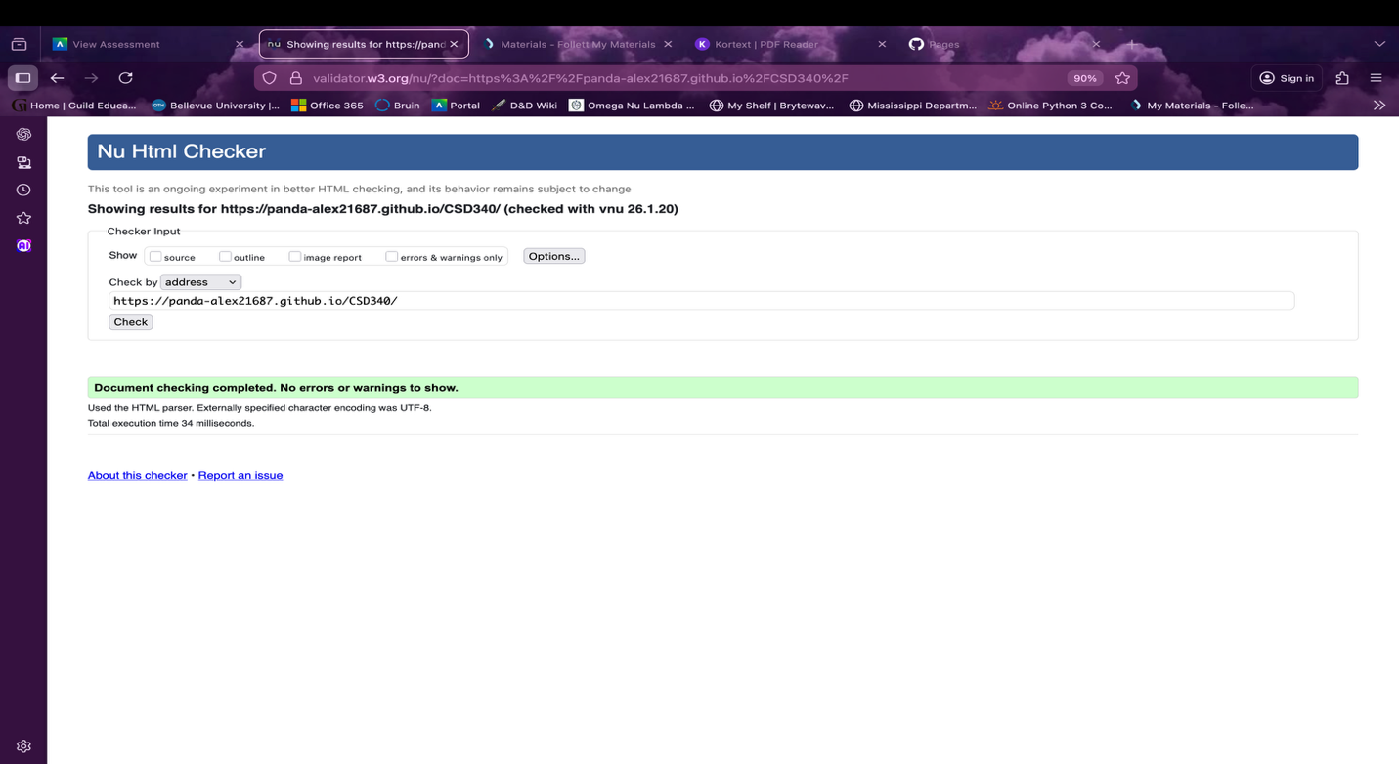

CSS Validator:
